**IBM Automation Foundation Assets Instance Creation**

1. Access the Platform Navigator. Login to the RedHat OpenShift Container Platform Console using the url, userid and password.

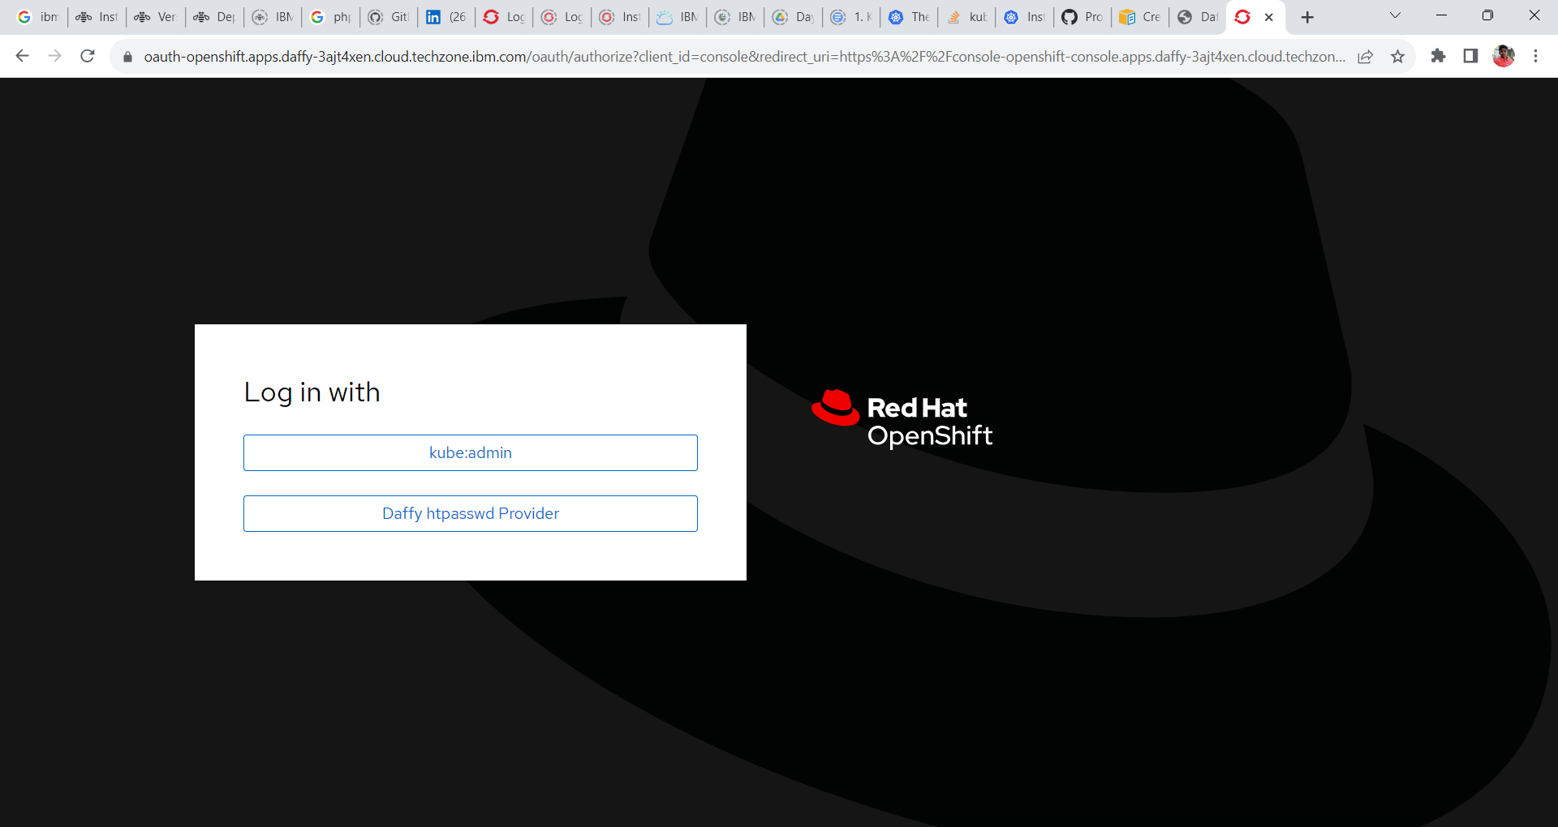

2. Goto Network -> Routes and change the project to CP4I.

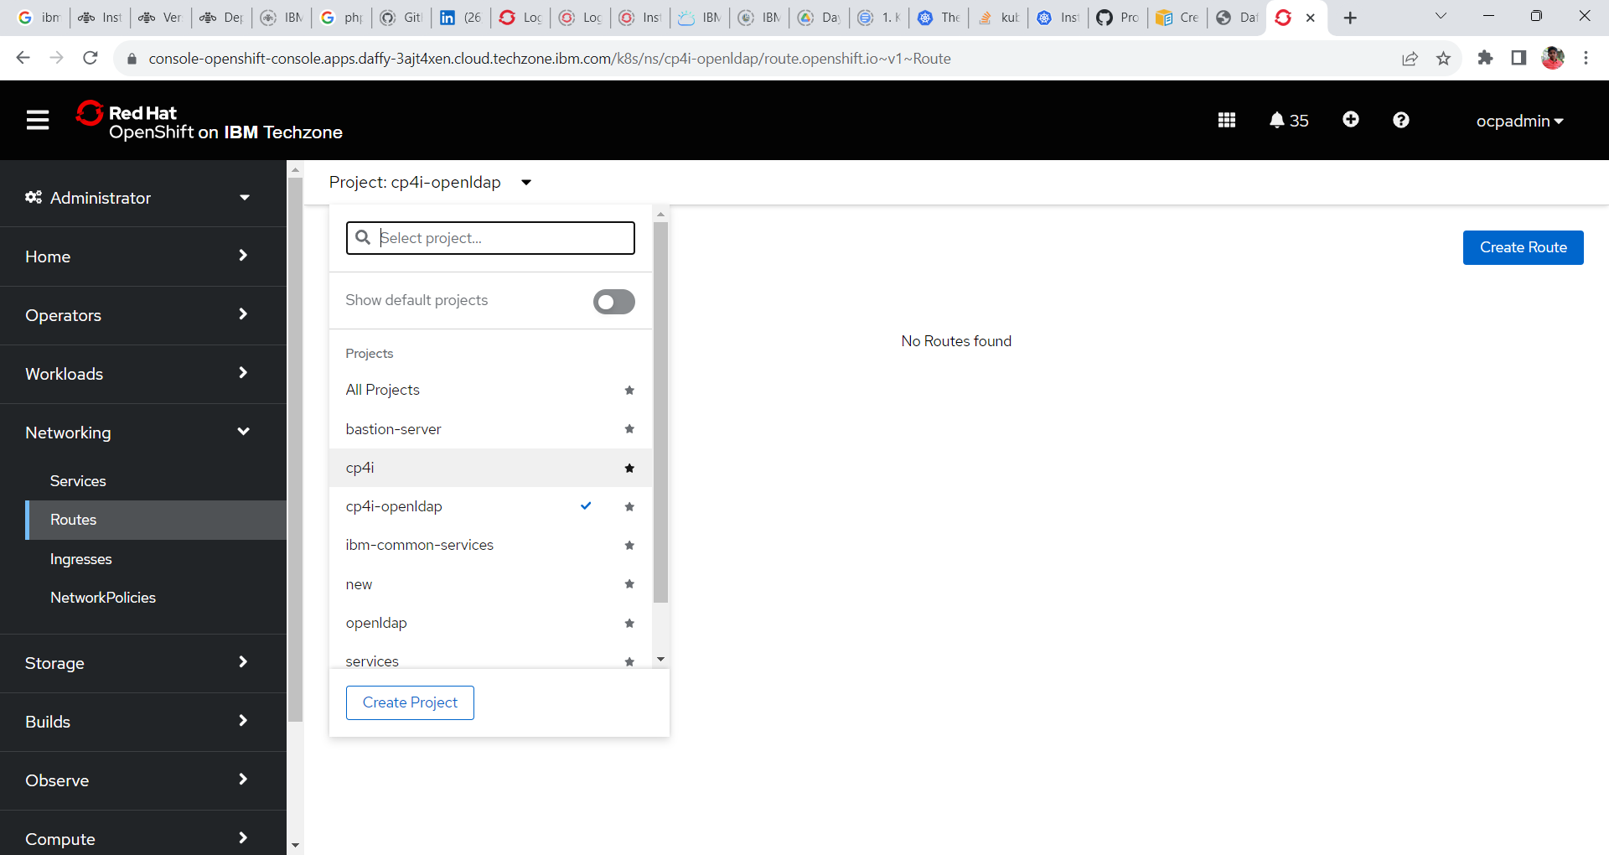

3. Search for Platform-navigator-pn or the name of the platform navigator you have provided and click on the url under location tab to open cp4i Platform UI.

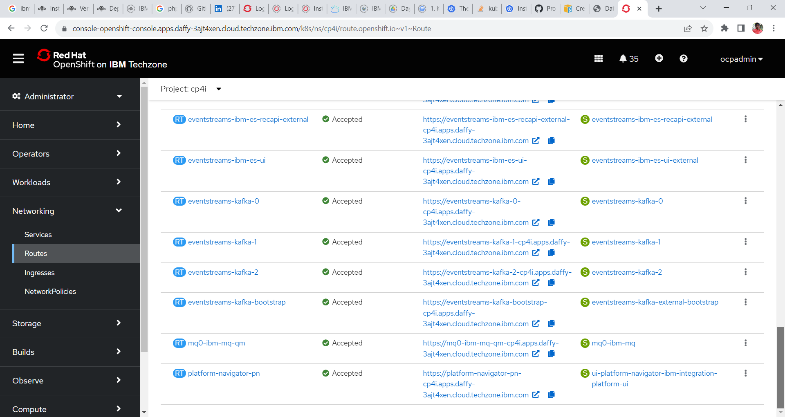

4. On clicking, cloud pak for integration Platform Navigator login screen is seen.

**Log in with = IBM Provided credentials**

**Username = admin**

**Password = < Need to accessed from secrets>**

**Access the password for platform navigator**

1. In OpenShift Web Console go to **Workload -> Secrets** and change the project **ibm-common-services**.

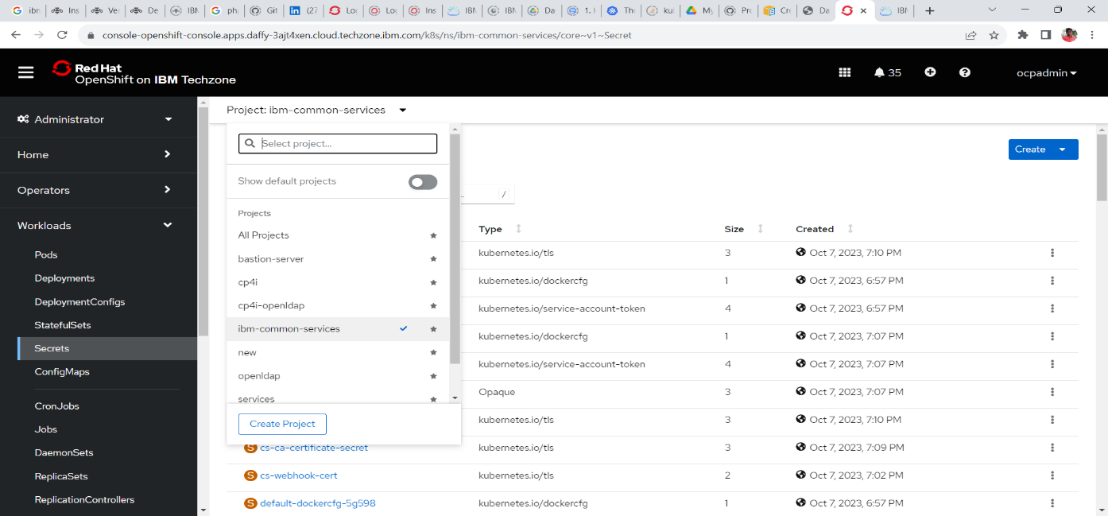

2. Search for the following secrets **platform-auth-idp-credentials** and click to open the same.

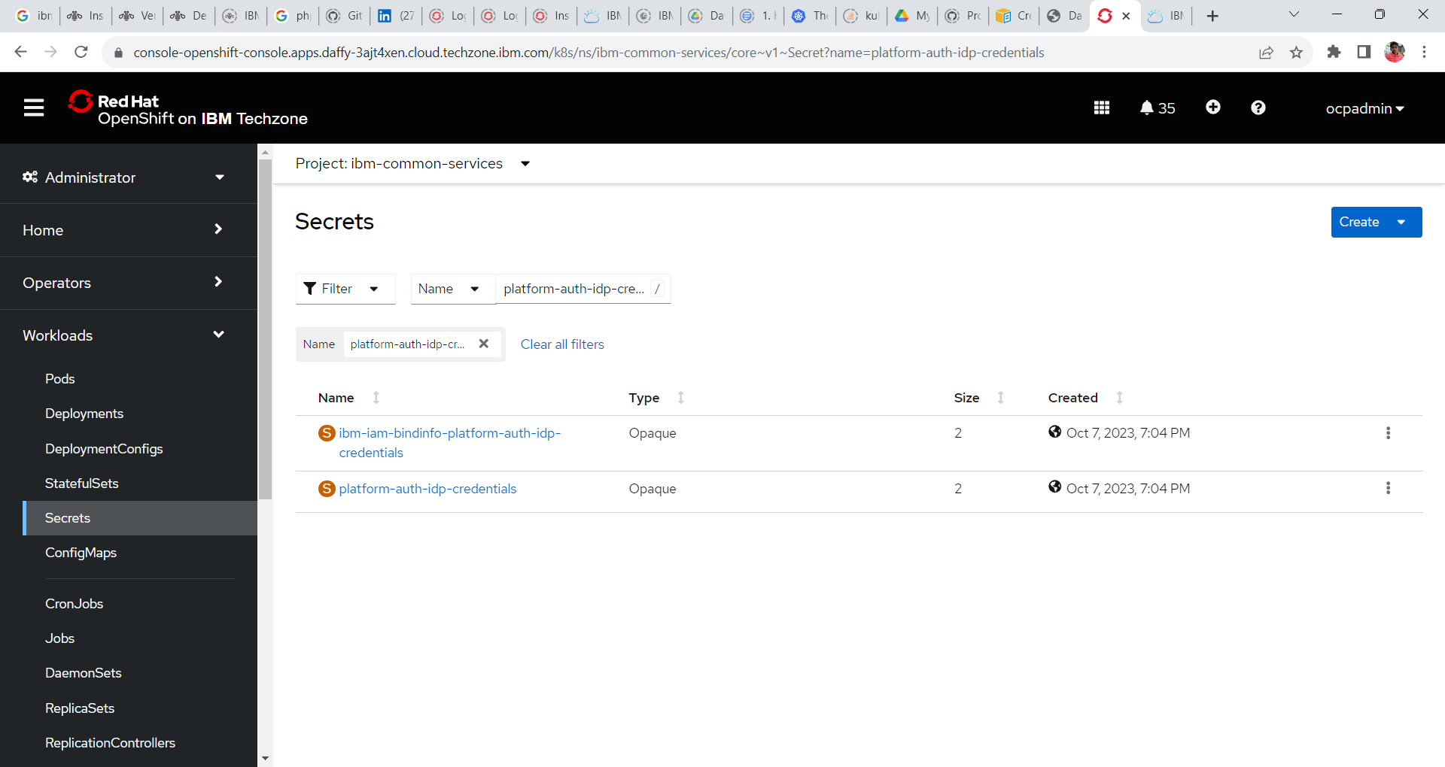

3. Goto the bottom of the screen and click on reveal values to reveal the username and password for the CP4I platform UI.

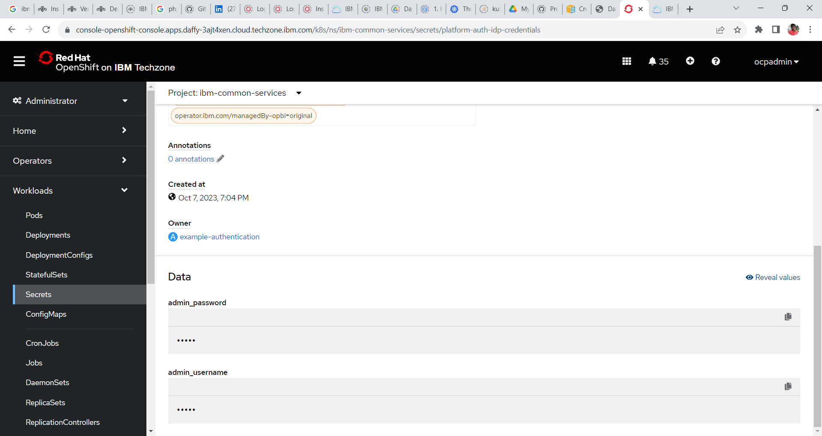

4. Copy the password and login to CP4I platform Navigator.

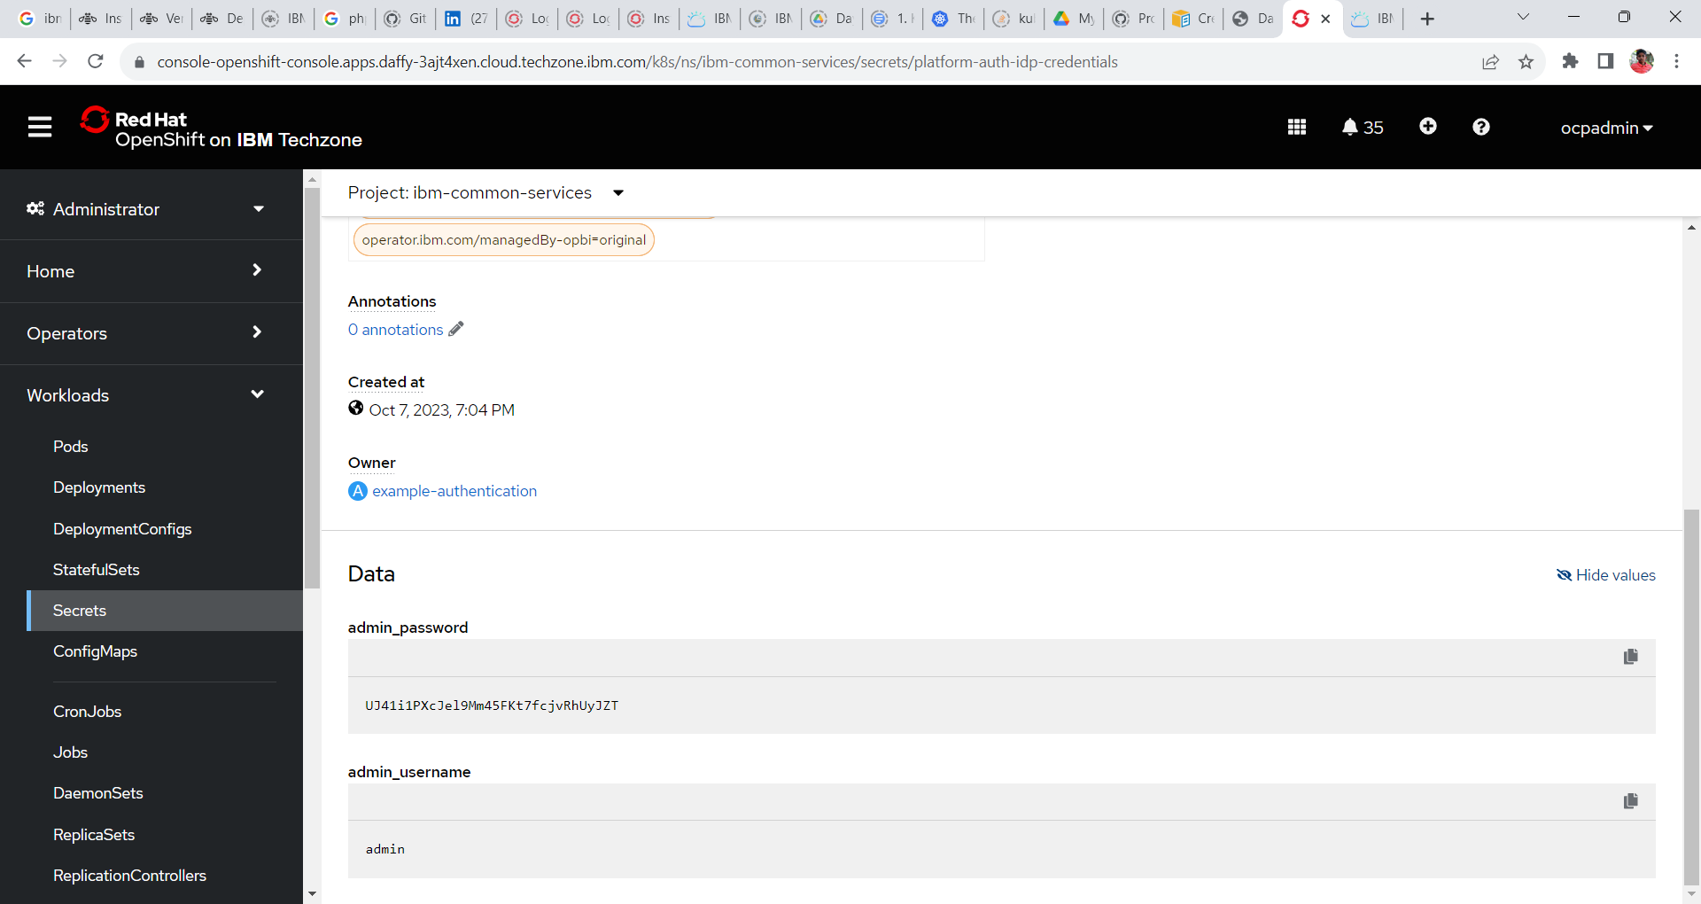

**Click to copy.**

**Platform Navigator**

5. Login to the platform Navigator

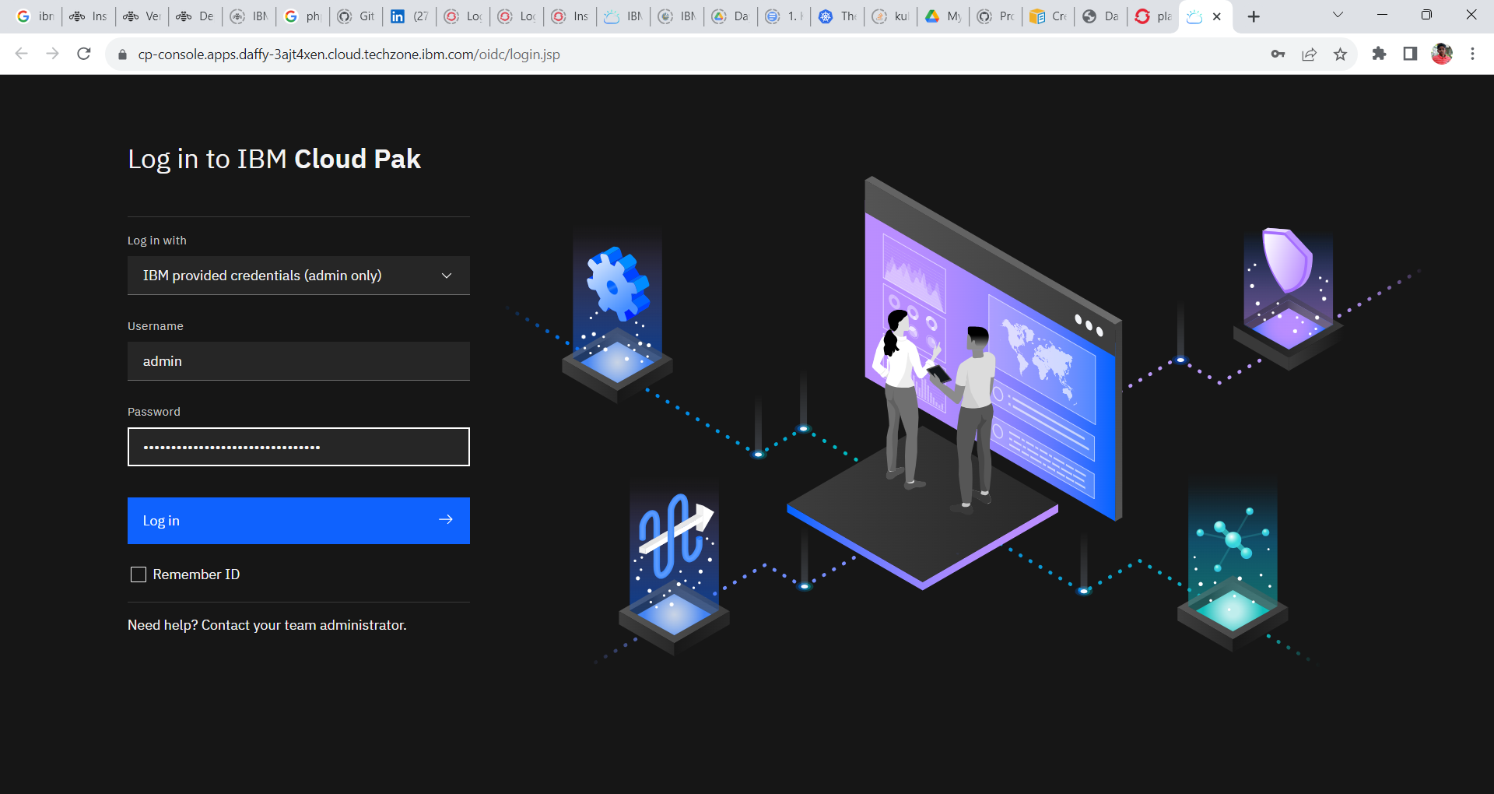

6. Click the integration instances tile or click on menu and click Administration and click on Integration Instances.

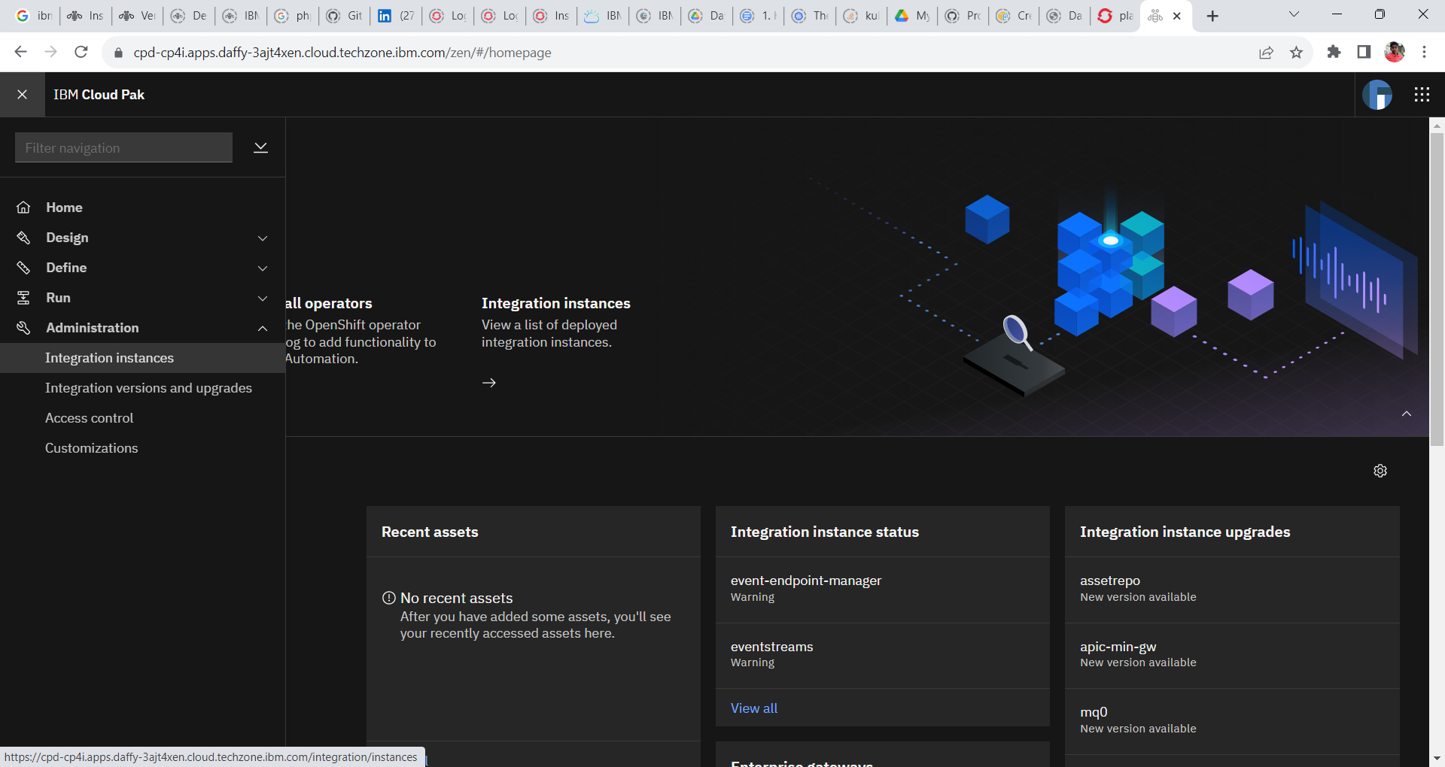

7. To create an instance of IBM MQ click Create Instance in the window

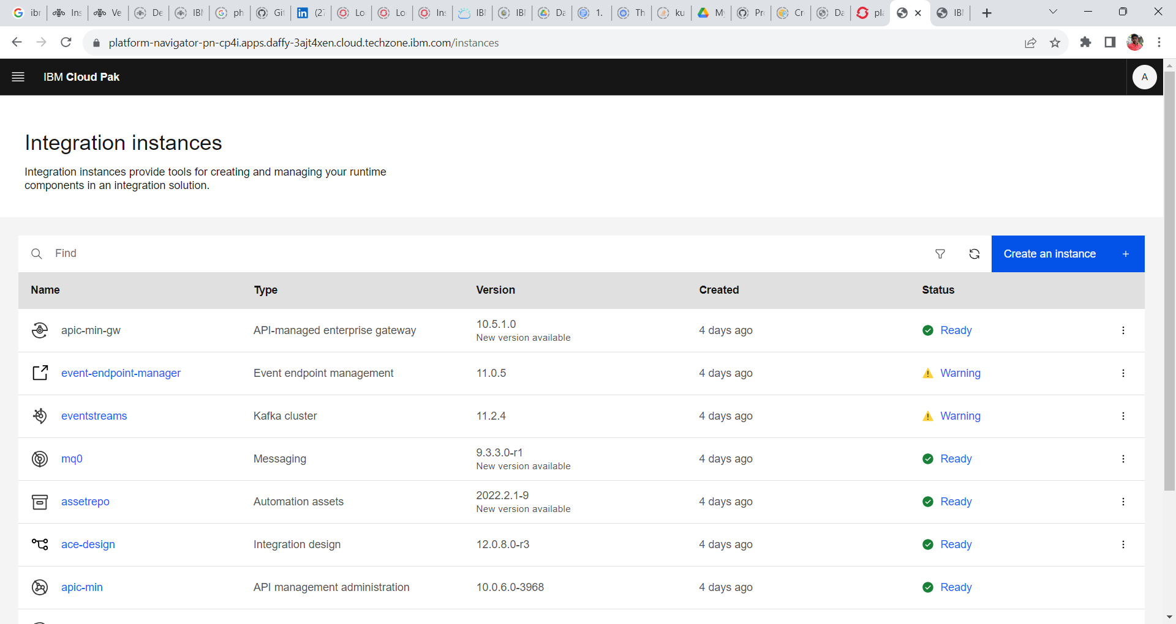

8. Select the Automation Asset tile and click Next. The message tile will be enabled if the IBM Automation Foundation Asset operator has successfully installed.

9. Next window displays the Sample tiles through which we can create the instances. Select the Single Fixed Replica and click next.

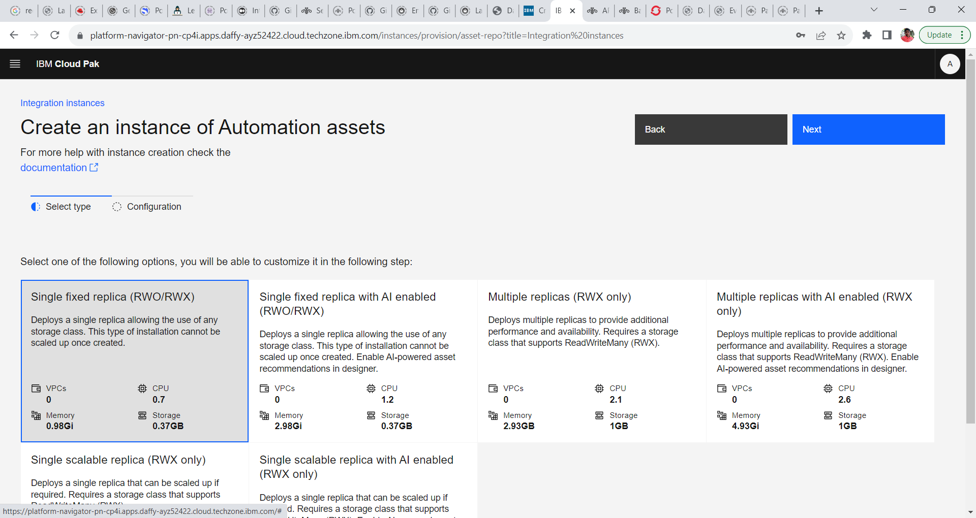

10. Provide the following configuration.

**Name : fixed-single**

**Namespace: cp4i**

**License : Accept the License**

**Storage:**

**Asset Data Storage Class: ocs-storagecluster-cephfs**

**Asset Metadata Storage Class: ocs-storagecluster-ceph-rbd**

**Version: 2022.2.1-20**

10. Click **Create**. Wait for few minutes for it to spin the instance of IBM Automation Foundation.

11. Once the instance installed and the status is ready, click on the name of the Automation Foundation to open up the instance.

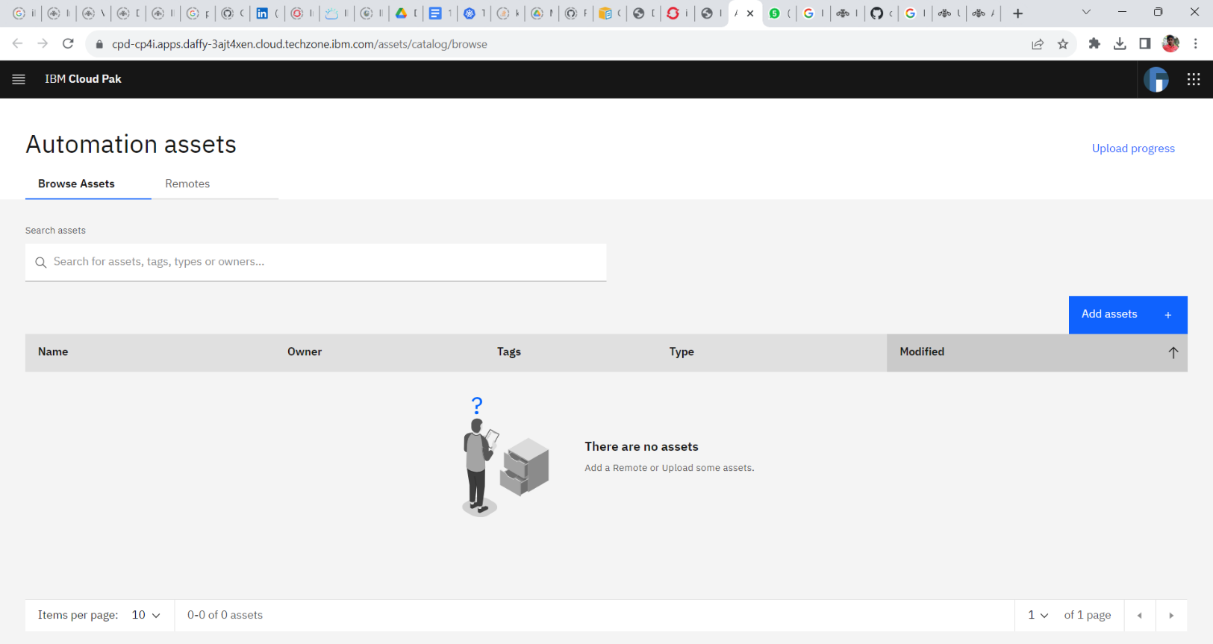12. Automation Foundation Asset Dashboard

13. Let’s check the Integration Dashboard pods created. Login into the Red Hat OpenShift Console. Expand **workloads** and click **pods**.

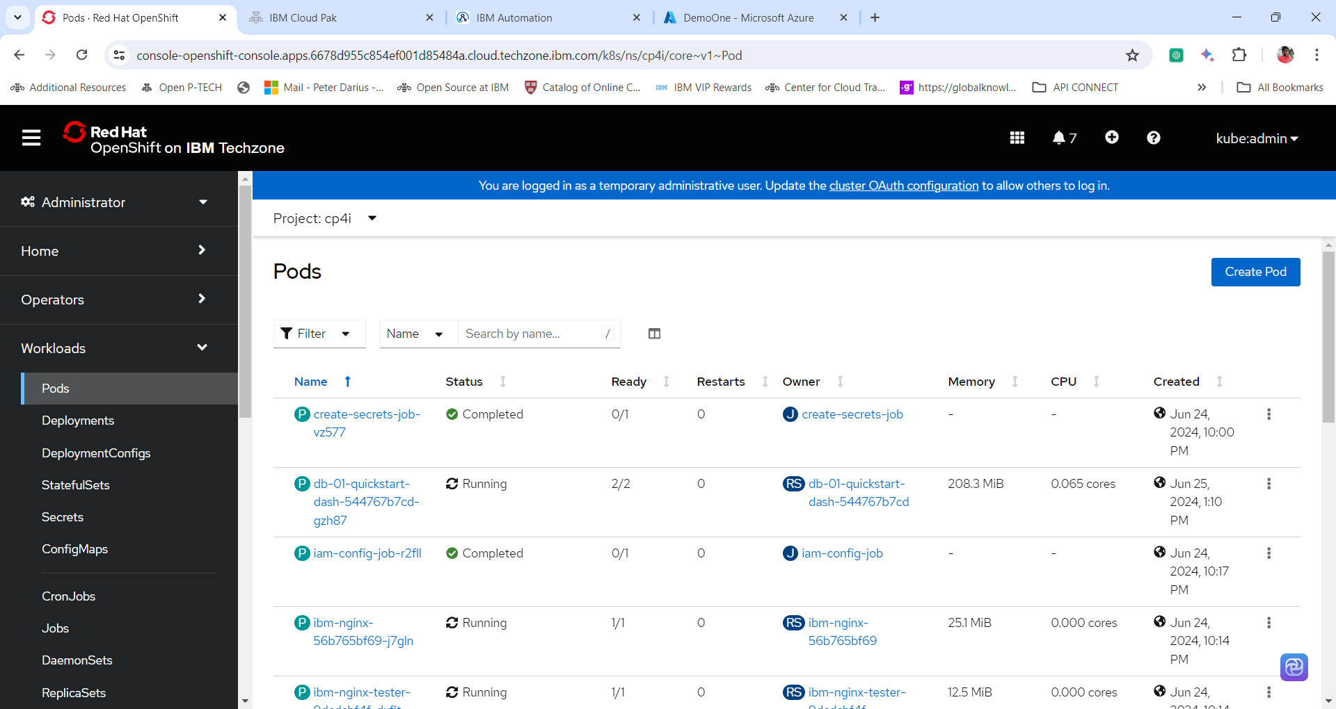

14. Change the **project Name to cp4i**. In the **search box** search integration dashboard pod by giving integration instance name i.e **fixed-single.** And click the integration pod name to view the details of the pod.

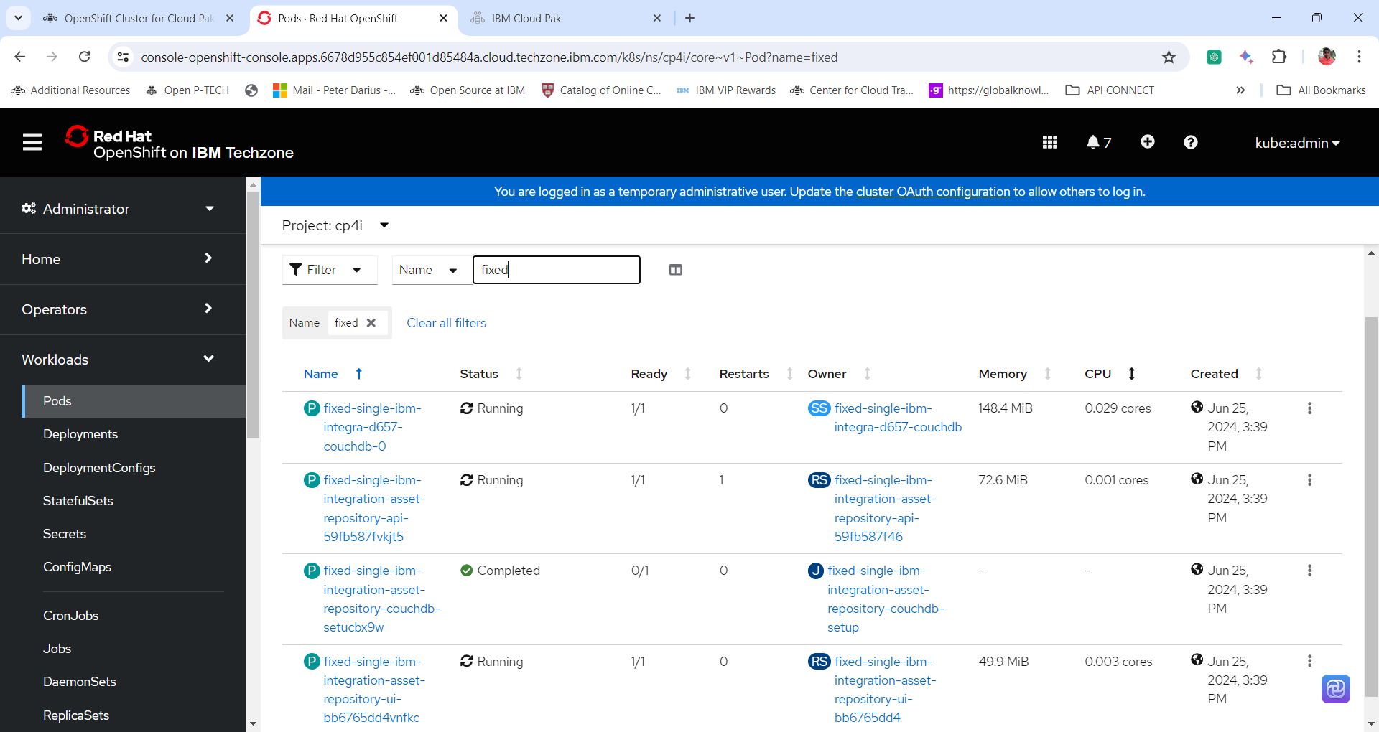

**Adding a Remote Asset**

1. The Automation assets can include assets in a remote Git repository. Any Git implementation can be used, as long as it supports one of the following:

* No authorization
* SSH key authorization

Assets stored in a remote repository are read-only.

Click **Remotes** on the Automation assets. The Remote listing page appears.

2. To add a new remote repository, click **Add Remote**. A blank configuration page appears. Complete the fields as needed.

Provide the following details to configure the Remote Asset.

**Name: newasset**

**Asset Types: Select All**

3. When creating a remote you can select the interval at which remotes are synchronised. This can be done by selecting the dropdown menu under the Automatic sync options tab, and select from one of the possible intervals.

**Automatic Sync Options: Hourly**

4. After adding the remote URL, you can select a remote branch by selecting the branch from the drop down menu under the Branch label.

**Remote Details | Git URL:** [**https://github.com/OAI/OpenAPI-Specification.git**](https://github.com/OAI/OpenAPI-Specification.git)

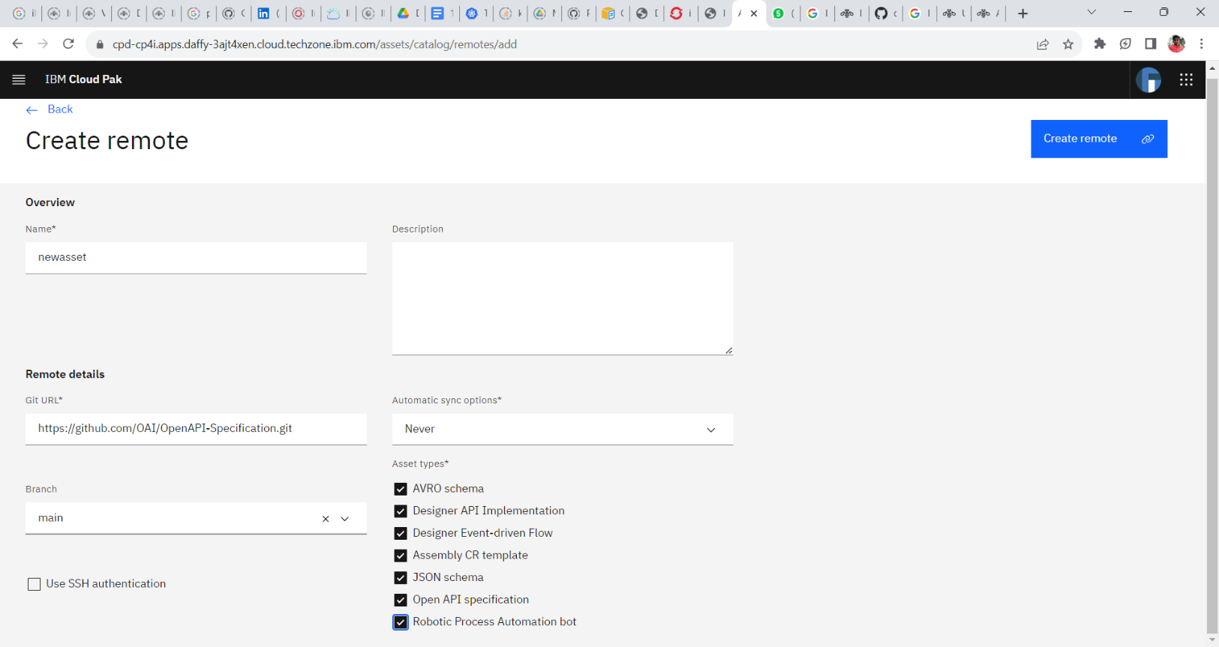**Branch = Main**

5. Click **Create Remote**. Once the synchronization completes, you see the remote listed.

6. Click on the **Browse Assets** tab and view all the remote assets.

**Additional Reading**

**SSH Key Auth**

You can use an SSH key to access the remote repository. To use SSH, follow these steps.

1. Select Use SSH authentication.
2. Copy the key presented in the dialog.
3. Configure your Git repository to use the copied key. For Github, see <https://docs.github.com/en/enterprise-server@3.10/authentication/connecting-to-github-with-ssh/adding-a-new-ssh-key-to-your-github-account>
4. Set the Git URL to the correct address. For a Github repository, this address begins with git@github.com.

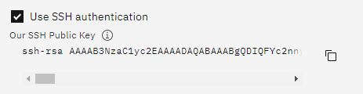

If you configured Automation assets to automatically synchronize with the remote repository, take these additional steps:

1. Click **Remotes** to see the list of available remote repositories.
2. Click the Edit￼ **Edit** icon for the remote you want to edit.
3. Select Never in the **Automatic sync options** field.
4. Click Edit Remote. The screen will return to the list of available remotes.